Education: The child’s perspective
A PPP by Per and Therése Ewert
How family and school in cooperation can shape the best environment for children’s upbringing

Think this seems hard?
No worry, you’re in good company!

The global scene
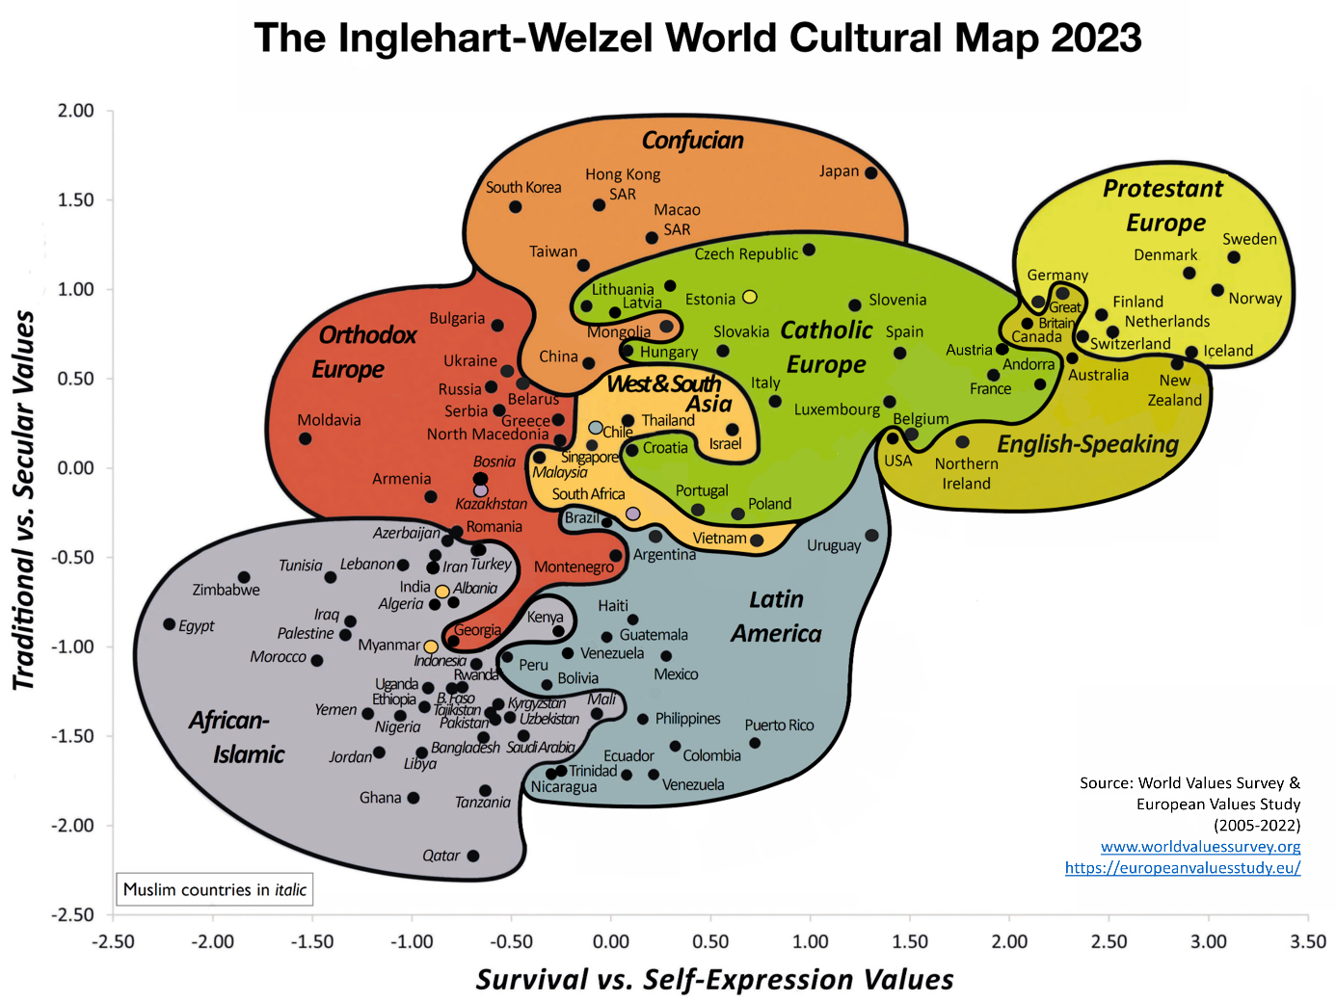

The three crucial battlefields

But Jesus knew their thoughts, so he brought a little child to his side. Then he said to them, “Anyone who welcomes a little child like this on my behalf welcomes me, and anyone who welcomes me also welcomes my Father who sent me. Whoever is the least among you is the greatest.” Luke 9:47

Discuss!
- 1. Which major differences in society do you see between when you grew up and today?
- 2. What do you think are the biggest challenges in being an adult, parent/teacher today?

Spiritual health: a need for every person
- A 700% increase in 30 years. The stones cry out!
- Psychiatric illness often arises out of a reduced view of the human being.
- WHO and others highlight the existential factor in public health.
- Bring back the larger picture, human dignity.

Children’s right to spiritual health
UN Convention on the rights of the child, Article 6
1. States Parties recognize that every child has the inherent right to life.
2. States Parties shall ensure to the maximum extent possible the survival and development of the child.
Article 17
…recognize the important function performed by the mass media (…) especially those aimed at the promotion of his or her social, spiritual and moral well-being and physical and mental health.
Article 23:3
Recognizing the special needs of a disabled child (…) to the child’s achieving the fullest possible social integration and individual development, including his or her cultural and spiritual development
Article 27:1
…the right of every child to a standard of living adequate for the child’s
physical, mental, spiritual, moral and social development.
Article 29:1
… that the education of the child shall be directed to: …(c) The development of respect for the child’s parents, his or her own cultural identity, language and values
Article 32:1
…the right of the child to be protected from economic exploitation and from performing any work (…) harmful to the child's health or physical, mental, spiritual, moral or social development.

Who is the primary protector of children’s rights?
UN Declaration of Human rights, Article 26
1. Everyone has the right to education. (…)
3. Parents have a prior right to choose the kind of education that shall be given to their children.
International Covenant on Economic, social and cultural rights, Article 13:3 “…have respect for the liberty of parents and, when applicable, legal guardians to choose for their children’s schools (…) to ensure the religious and moral education of their children in conformity with their own convictions.”
EU Treaty, Article 14:3
the right of parents to ensure the education and teaching of their children in conformity with their religious, philosophical and pedagogical convictions shall be respected
European Convention of Human rights, Protocol No1: Article 2
The State shall respect the right of parents to ensure such education and teaching for their children in conformity with their own religious and philosophical convictions.

What does the fairy tale teach us? (The emperor’s new clothes)

A Biblical view on the human: In accordance with psychological science
- A system for seeking closeness
- A system for exploring
Jesus said both Come! and Go!
To follow – a double habit (Matt 16:24)
A secure base, a safe harbour
A model for both parents and school

Endurance
- ”Our willingness to wait reveals the value we place on the object we´re waiting for.” Charles Stanley
- Endurance necessary in order to do God’s will and receive what he has promised. Hebr 10:36
- Patience not a quality we’re born with. Jesus’ strategy can be ours. Hebr 12:2

Waiting for something good…

The Self
- The authentic core within each person
- Ps 139: God saw the human and gave him a bag of gold to invest.
- ”Ego weakness” – an ignored problem, despite serious consequences.
- E.g. borderlessness, confusion and fragmentation

Congruence
Different characters – same person

Encouragement
- The compliment club, 1920s
- It is more blessed to give than to receive!
- The Golden Rule
- Bonus effects from good deeds: ”When you feel down, go and be a blessing to someone else!”

Responsibility
- Bystander effect
- Dispersion of responsibility

Empathy – Feeling the pain of the other
- Strong decrease during the 20th century, according to research
- Possible explanations?
  - Stress, internal and external
  - The enormous flow of information
  - Individualism and materialism
  - Empathy needs and can be actively practiced.

The tendency to find reasons for problems outside yourself

Conformity
- ”The truth has to move due to the need of belonging to the group.”
- Daniel’s three friends in the fiery furnace: when conviction remains in your inner being.
- Rom 12:2: Do not conform to the pattern of this world
- God asks the OT prophets: -What do you see?

Authority - who do we follow and why?
- Milgram and Asch, experiments of social psychology, 1950s

Discussion: Conformity -To follow the crowd
Give examples of situations where you have experienced conformity. How did you and others handle these?
What statues ask for our devotion today?
How can we and our children be best prepared to handle these demands of peer pressure?

Challenges for the child in our time
Norm criticism through popular media

Affirming your child. What does Desmond search for?

Relations and sexuality – some current examples
Lobby organizations acting monopoly in schools
The Pride Movement: Breaking of norms with serious consequences for public health

Sweden’s main cultural war 2023
”Lady Busty and Miss Shameless”

A different voice
For schools and churches

Ideologized results with no or skewed context
Central information omitted: Only 26 % response
Numbers including e.g.: Do not categorize myself in sexual terms, Don’t know
Four times larger than those identifying as homosexual
Results presented to media, politicians and public as facts, even when not.

Research says…
Established is: Vast change over time
Americans' Self-Identification as LGBT, by Generation
Traditonalist (born before 1946) 1.3
Baby boomers (born 1946-1964) 2.0
Generation X (born 1965-1980) 3.8
Millennials (born 1981-1996) 9.1
Generation Z (born 1997-2002) 15.9

Vast majority among these, 72 % identify as bisexual, followed by trans
Strongest correlation in all age groups: ideological
Liberals: 13 % identify as LGBTQ, Conservatives: 2%

The actual perspective
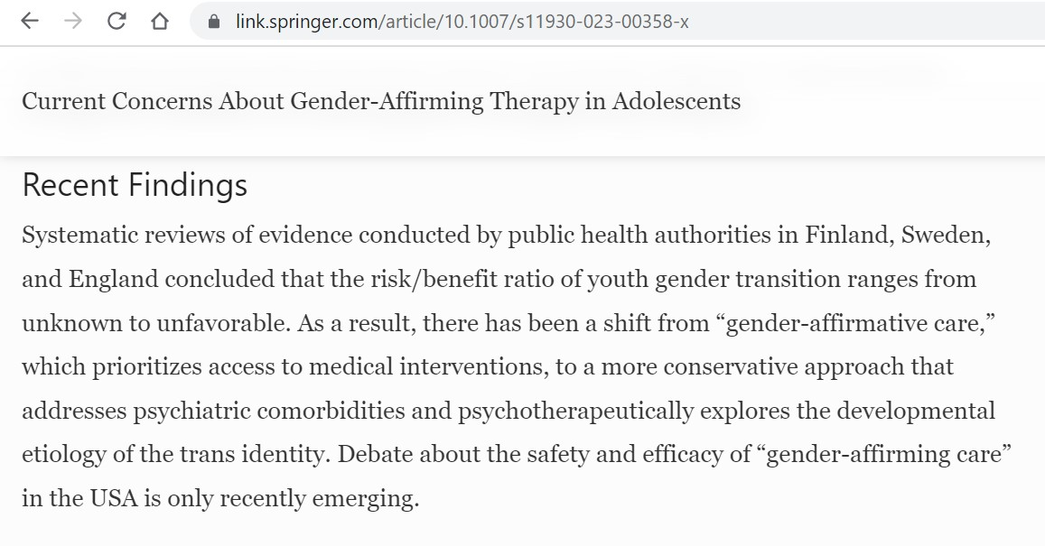

The question where most Swedish teenagers want more information in sexual education
How do you make a relationship hold together?

School and family – building values together
Discuss!
- 1. Which needs of the child are most important for parents and school to care for together?
- 2. What can a shared responsibility look like? In what areas should school and parents respectively have the main responsibility?
- 3. How can school and family have a good dialogue and cooperation during a child’s years in school?

Check facts – reveal when false or misleading
Keep the children’s actual needs at the centre
Let perspective, truth and agape/love lead the way

Train a child in the way he should go, and when he is old he will not turn from it. Prov 22:6

